**Name : ABID ALI**

**Student_No : 2019380141**

**Assignment 8.1**

**7.5** Prove each of the following assertions:

**a**. α is valid if and only if True |= α.

**b**. For any α, False |= α.

**c**. α |= β if and only if the sentence (α ⇒ β) is valid.

**d**. α ≡ β if and only if the sentence (α ⇔ β) is valid.

**e**. α |= β if and only if the sentence (α ∧ ￢β) is unsatisfiable.

**Solution:**

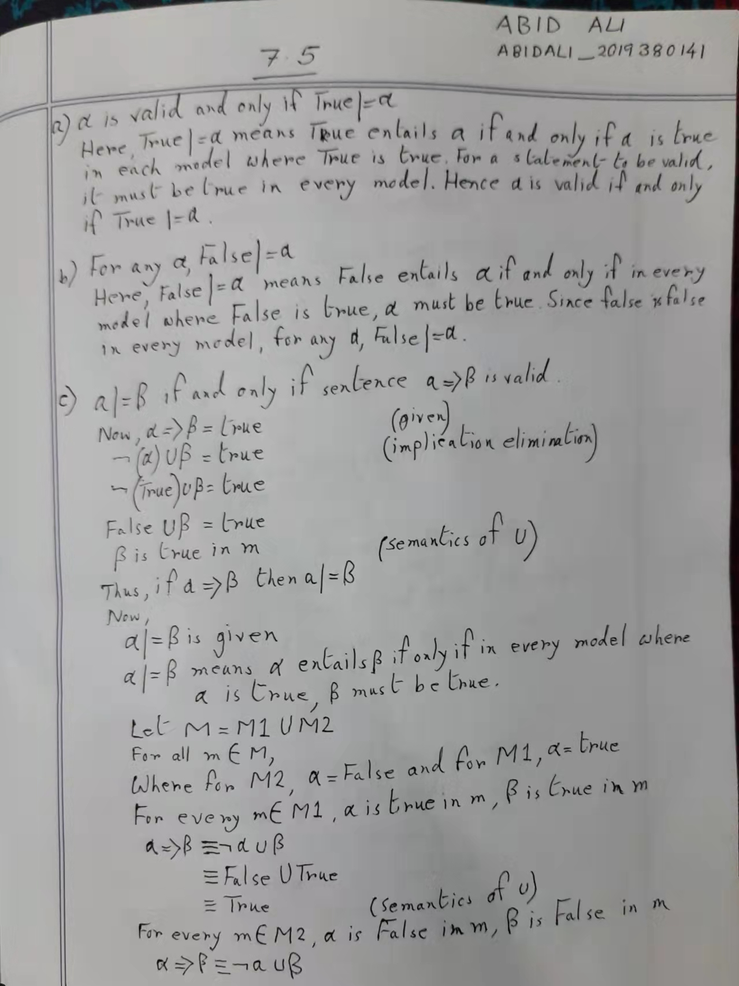

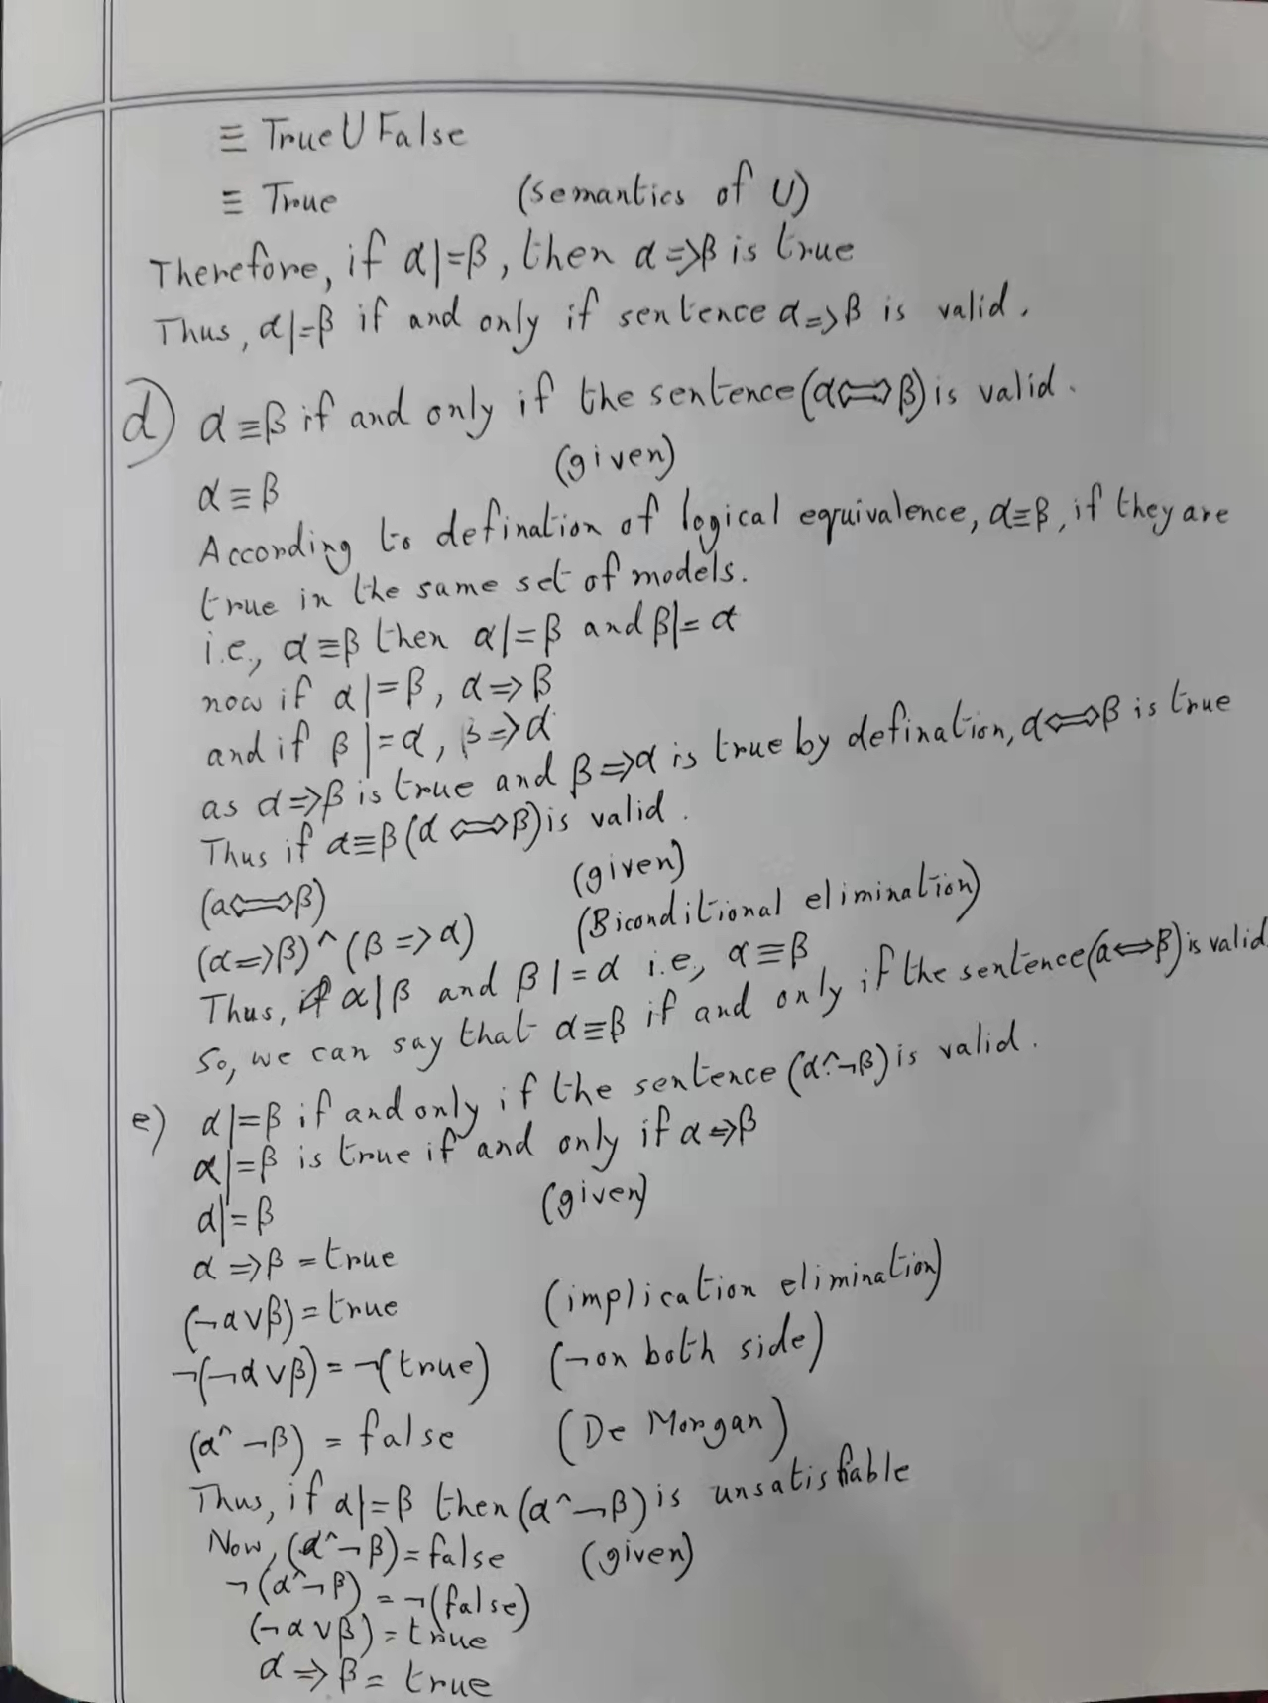

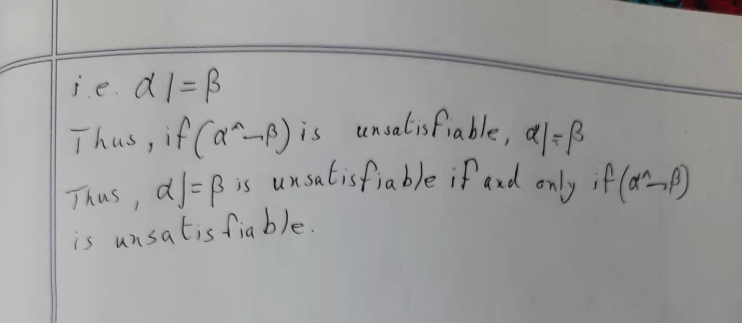

**7.10** Decide whether each of the following sentences is valid, unsatisfiable, or neither. Verify

your decisions using truth tables or the equivalence rules of Figure 7.11 (page 249).

**a**. Smoke ⇒ Smoke

**b**. Smoke ⇒ Fire

**c**. (Smoke ⇒ Fire) ⇒ (￢Smoke ⇒ ￢Fire)

**d**. Smoke ∨ Fire ∨ ￢Fire

**e**. ((Smoke ∧ Heat ) ⇒ Fire) ⇔ ((Smoke ⇒ Fire) ∨ (Heat ⇒ Fire))

**f**. (Smoke ⇒ Fire) ⇒ ((Smoke ∧ Heat ) ⇒ Fire)

**g**. Big ∨ Dumb ∨ (Big ⇒ Dumb)

**Solution:**

